Workshop 8: Use CSV Data in Hadoop, Apache Spark
Grishma lamsal
2431171

Table of contents
1. Working with Found Datasets 1
2. Hadoop and Comma Separated Values (CSV) Files 1
2.1 Population Data: Population.java 1
2.2 Running the Program 3
2.2.1 Exercises to do 5
3. Apache Spark 6
3.2 Student.json 7
3.2.1 Using Data Frames 7
3.2.2 Using SQL Queries 8
3.2.3 Exercises to do 9
3.3 Exiting Apache Spark 9
3.4 Weather.json 9
3.4.1 Using Data Frames 9
3.4.2 Using SQL Queries 12
4. Spark and CSV Files 14
4.1 Spark Queries 15
4.2 Using SQL 15
4.2.1 Exercises to do 16
4.3 HDFS and Apache Spark 16
4.4 Final Word Count 17

Before starting the below tasks make sure that you have :

- Switched to the hadoop user.
- Navigated to the hadoop Sbin directory.
- Started the Hadoop Distributed File System (HDFS).
- Started the YARN Resource Manager.
done

If jps (Java Processing Status) lists all the above running java processes, then you are good to go.

Working with Found Datasets
This workbook assumes you have completed Workshop 7 and are familiar with how to access and run Java programs using Hadoop.

So far the examples have worked with simple text files with no particular structure. To be a meaningful tool Hadoop and its associated projects need to be able to work with more complex data, such as the Excel and JSON data files.

Hadoop and Comma Separated Values (CSV) Files
CSV files can also be used in Hadoop.

2.1 Population Data: Population.java

The following program will work with the pop.csv file. The Word Count examples looked for spaces and punctuation to separate words, whereas in the CSV files, the data will be separated by commas.

The Program is

Population.java

The process is similar to the Word Count programs in that it imports some data and splits the data based on some criteria. Instead of just counting the words found, this program will total up the population values for each County and count how many rows there were. The County Names are
the key in this case.

Mapping Stage

In CSV files, the data will be separated by commas, so we need to tell Hadoop to split using this:

String record = value.toString();
String[] parts = record.split(",");

Reducer Stage

By default, Hadoop uses tab (\t) characters to separate words when outputting the results. In this case we are going to output the final results also using commas, so the results could be treated as another CSV file. The output includes both the key and value, the following separates the values using a comma:

for (Text t : values) {
String parts[] = t.toString().split("\t");
popCount++;
popTotal += Integer.parseInt(parts[0]);
} // for loop
String str = String.format("%d,%d", popCount, popTotal);

For the key we need to change a configuration parameter to change the default:

Configuration conf = new Configuration();
//set output delimiter to comma
conf.set("mapreduce.output.textoutputformat.separator", ",");

Delete the Output File

In the Word Count examples, we had to ensure we always deleted the hdfs output directory before running the program.
This program is a bit more sophisticated in that it will delete the folder for you:

Path outputPath = new Path(args[1]);
FileOutputFormat.setOutputPath(job, outputPath);
// Delete the output directory - true means if path is a directory it does recursive delete
outputPath.getFileSystem(conf).delete(outputPath, true);

2.2 Running the Program
Before running the program we need to download the necessary files from the below drive link.

👉 workshop 8

- Download both json.zip and csv.zip.

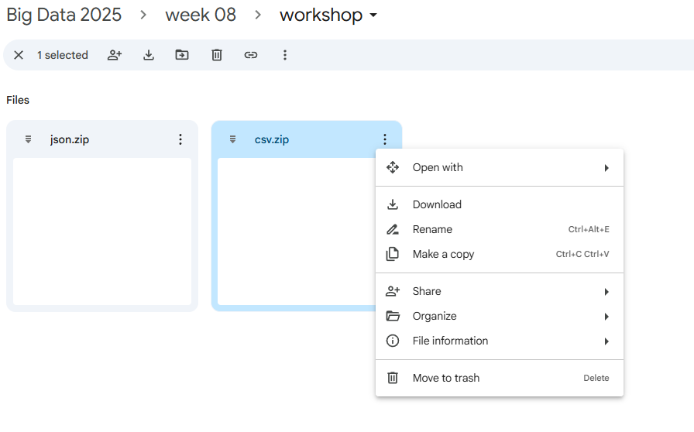
- After downloading them, extract them in the same Downloads folder.

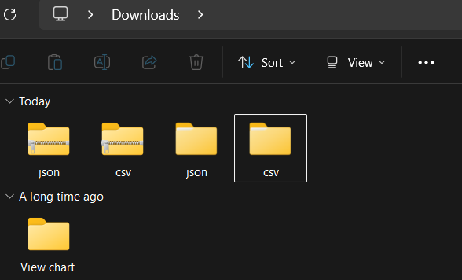

- From the Ubuntu terminal, copy the program Population.java, pop.csv, and Pay.csv to your linux home directory.

~$ cp /mnt/c/Users/YourWindowsUsername/Downloads/csv/csv/Population.java ~/

~$ cp /mnt/c/Users/YourWindowsUsername/Downloads/csv/csv/Pop.csv ~/

~$ cp /mnt/c/Users/YourWindowsUsername/Downloads/csv/csv/Pay.csv ~/
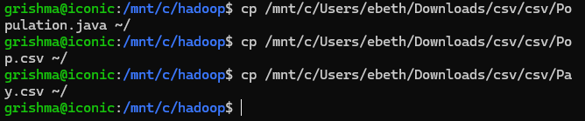

Important: Don’t forget to replace “YourWindowsUsername” with your windows username.

- Compile the program first and then create a jar file.

~$ cd

~$ javac -classpath $(hadoop classpath) Population.java

~$ jar cf Population.jar Pop*.class
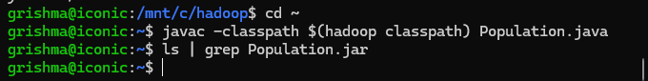

- Create a new input directory called input_csv and store the pop.csv as well as pay.csv file there.

~$ hdfs dfs -mkdir /input_csv

~$ hdfs dfs -put Pop.csv /input_csv

~$ hdfs dfs -put Pay.csv /input_csv
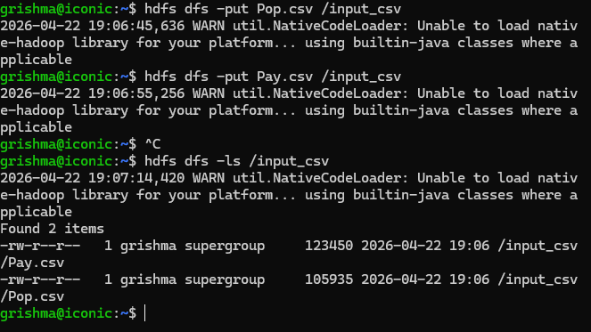

- Run the file:

~$ hadoop jar Population.jar Population /input_csv/Pop.csv output_csv

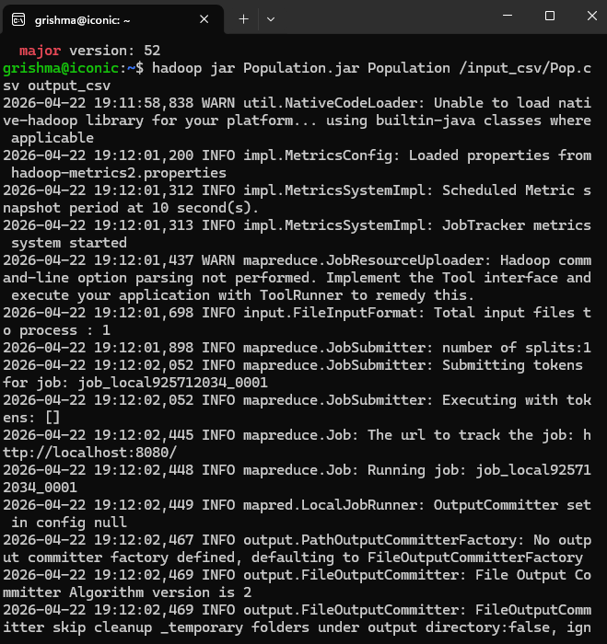
- Check if the output file has been created:

~$ hdfs dfs -ls output_csv
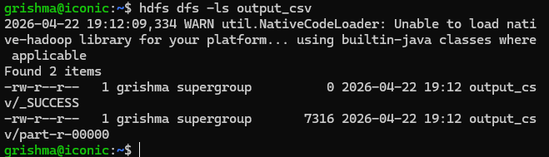
- View the results:

~$ hdfs dfs -cat output_csv/part-r-00000

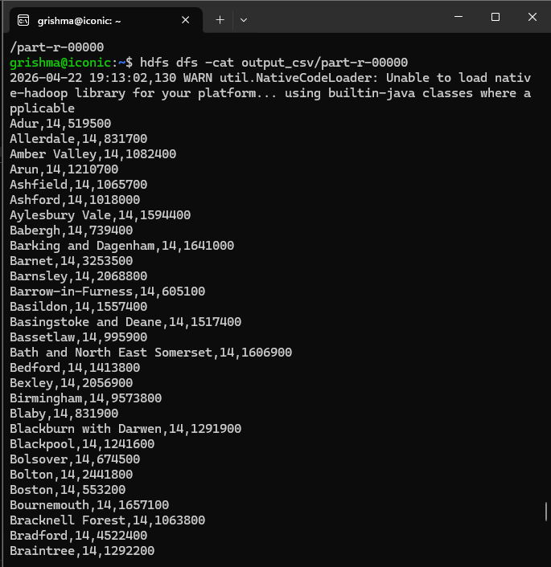
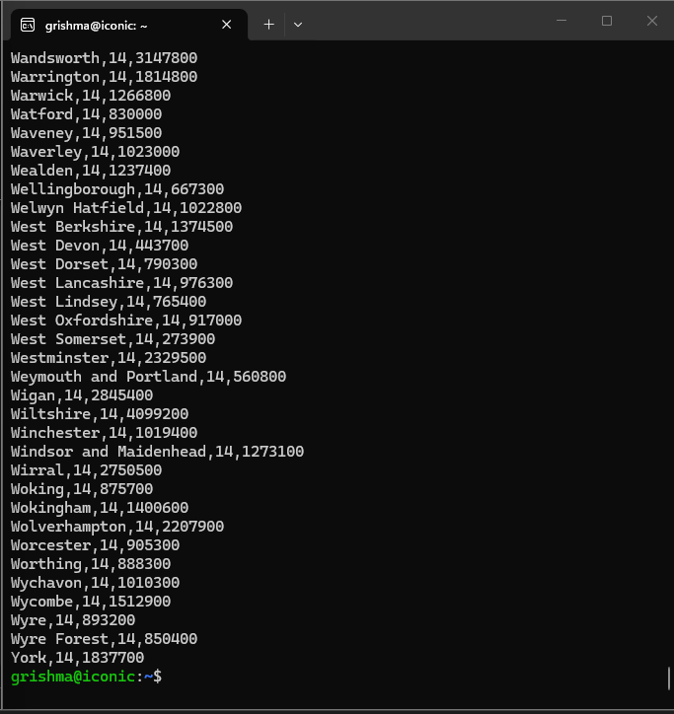
- To retrieve the results to a csv file:

~$ hdfs dfs -get output_csv/part-r-00000 results.csv
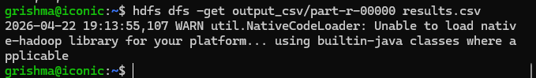

- The results.csv can be viewed using normal operating system commands such as:

~$ more results.csv
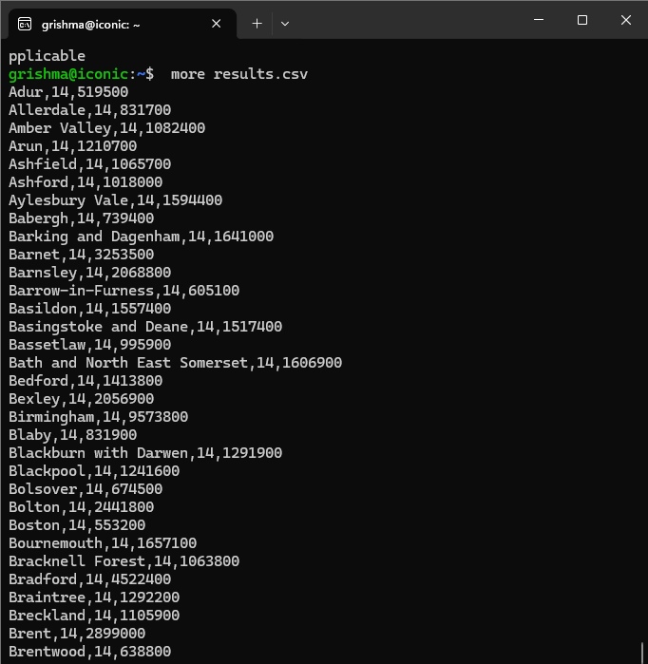

One thing to note is the first line containing the column names no longer exists, so if you wanted to import this data into something that expected this, such as Oracle, you would need to add this information first.

2.2.1 Exercises to do

- Pick some of the counties and check that the totals add up!

- Produce a Java file that handles the Pay data instead (pay.csv). One thing to note is that the pay totals are currency values, so the numbers will be a float rather than the whole numbers seen in the Population file. You will need to amend the code that handles the figures to account for this.

3. Apache Spark

There are many ways to access Apache Spark:

- pyspark – uses Python
- spark-shell – uses Scala
- spark-sql – to run SQL queries
- spark-submit – to run a program file, such as Python

Or you can access it via a Java program.

See this webpage for further details and examples:

👉 Spark SQL, DataFrames and Datasets Guide

The following examples will use pyspark, which allows you to use Python for any programminG tasks.
The weather.json dataset from the MongoDB tutorial will also be used for some of the examples, plus an extended version of the student.json file seen in the lecture. A copy of these files are available in the downloaded zip files:

weather.json
student.json

To access Spark from the operating system type:

~$ pyspark

To quit pyspark type and enter :

3.2 Student.json

The following example shows how a JSON file can be imported. A Spark session is automatically available using the spark variable.

3.2.1 Using Data Frames

The first examples will manipulate the data using a Spark DataFrame, this is equivalent to a relational table in SQL.

The Spark DataFrame is similar to the pandas DataFrame found in Python, but some of the methods and what they expect/return may differ slightly.

- Copy the student.json file to your linux home directory.

~$ cp /mnt/c/Users/YourWindowsUsername/Downloads/json/json/student.json ~/

- Start pyspark and create a DataFrame object based on the student.json file:

~$ pyspark

>>> df = spark.read.json("student.json")

- This stores the results in the df variable, which is a DataFrame. show() can be used to list the results:

>>> df.show()

- DataFrames are structured into columns and rows, to check what the schema is:

>>> df.printSchema()

- df represents a DataFrame object, so can be manipulated using methods associated with this data type. For example, to show just the name field:

>>> df.select("name").show()

- SQL-like operations can now be easily expressed:

>>> df.select(df['name'], df['age'] + 1).show()

- filter can be used to show only certain rows. To show students older than 21:

>>> df.filter(df['age'] > 21).show()

- groupBy is similar to the SQL GROUP BY command. To count how many students are on each course:

>>> df.groupBy("course").count().show()

3.2.2 Using SQL Queries

Spark implements a full SQL query engine which can convert SQL statements to a series of Resilient Distributed Dataset (RDD) transformations and actions. This second set of examples will use SQL to query the DataFrame.

- First the DataFrame can be registered as a SQL temporary view:

>>> df.createOrReplaceTempView("student")

- This means that “student” can be queried as if it was a SQL table:

>>> sqlDF = spark.sql("SELECT name, age, course FROM student WHERE age > 21")

>>> sqlDF.show()

3.2.3 Exercises to do

Using both forms of syntax (Data Frame and SQL) write code to:

- Show just the name and lives fields
- Count how many people live at each place.

3.3 Exiting Apache Spark

To leave the pyspark environment either type:

>>> exit()

Or press ctrl + d

The latter can be used in any of the Spark systems.

3.4 Weather.json

This example will use a larger dataset, such as the weather.json seen when using MongoDB.

Assuming you left pyspark in the previous section, copy the weather.json file into your linux home directory and restart pyspark.

~$ cp /mnt/c/Users/YourWindowsUsername/Downloads/json/json/weather.json ~/

~$ pyspark

3.4.1 Using Data Frames

This time load the weather.json file into a Data Frame and view some data:

>>> df = spark.read.json("weather.json")

>>> df.show()
By default show() only lists the first 20 rows. To show more rows, include a number to represent how many rows should be listed. For example, to show 40 rows:

>>> df.show(40)

This time the schema will be a lot more complex, to view it:

>>> df.printSchema()

How many records are there?

>>> df.count()

Show the first row:

>>> df.first()

Or the first two rows:

>>> df.take(2)

Show the summary statistics:

>>> df.describe().show()

This produces descriptive statistics for numerical columns, such as the count, mean and standard deviation. For example, the first row contains the counts:

>>> df.describe().first()

The dot notation can be used to view sub-documents. To show 40 of the user’s screen names:

>>> df.select("user.screen_name").show(40)

In a dataframe the field name must be in quotes. Either single or double quotes can be used, but you must be consistent.

>>> df.select ('user.screen_name').show(40)

but: df.select ('user.screen_name").show(40)
will generate an error message!

When testing for equality using a data frame, use double equals (==) for the test. For example, show the tweets where the language is English (en):

>>> df.filter(df['lang'] == "en").show()

To restrict both the rows and columns, a pipeline can be set up to pass one command to another:

>>> df.filter(df['lang'] == "en").select('user.screen_name', 'user.location').show(40)

This will retrieve the tweets where the language is English, then output just the screen name and location of the user.

By default Spark truncates long text fields, to avoid this use the Boolean False as a second parameter to show(). In this case you will also have to specify how many rows to show too.

Pattern matching can be done using the contains method. For example, find texts containing sun and show the full text field:

>>> df.select('text').filter(df['text'].contains("sun")).show(10, False)

3.4.2 Using SQL Queries

Create a temporary view containing the weather data:

>>> df.createOrReplaceTempView("weather")

The equivalent of the last data frame query is as follows (type on one line):

>>> sqlDF = spark.sql("SELECT user.screen_name, user.location FROM weather WHERE lang = 'en' ")

This time the field names do not need to be in quotes and the test for equality is a single equal sign. spark.sql takes a SQL string as a parameter which must be in either single or double quotes. The query includes a test for a string (en), which must be in different quotes to the SQL query – only single (') or double quotes (") should be used.

For example, the above used double quotes for the SQL query, then single quotes for the value. The following will also work, where single quotes are use for the SQL query and double quotes for the value test:

>>> sqlDF = spark.sql('SELECT user.screen_name, user.location FROM weather WHERE lang = "en" ')

What you cannot do is the use the same sort of quotes for both, so the following will not work:

sqlDF = spark.sql('SELECT user.screen_name, user.location FROM weather WHERE user.lang = 'en' ')

To show 50 rows from the results:

>>> sqlDF.show(50)

Most standard SQL commands will work. For example, count how many records there are:

>>> sqlDF = spark.sql("SELECT count(*) AS weather_count FROM weather").show()

Count by language:

>>> sqlDF = spark.sql("SELECT lang, count(*) AS language_count FROM weather GROUP BY lang").show()

The totals should add up to match the previous count!

The SQL LIKE command can be used for pattern matching. In MongoDB we listed just the Tweets containing sun in the text. The equivalent in SQL would be:

>>> sqlDF = spark.sql("SELECT text FROM weather WHERE text LIKE '%sun%' ").show()

To make the query case insensitive by forcing the text field into upper case characters:

>>> sqlDF = spark.sql("SELECT text FROM weather WHERE UPPER(text) LIKE '%SUN%' ").show(20, False)

4. Spark and CSV Files
Spark can also read CSV files, as well as JSON format. The following examples will use the pay.csv and pop.csv files seen in Section 2, however, we will use a version of the files that includes a header in the first row, which can be used for the column headings (pay-header.csv and pop-header.csv). This is the only difference from the files above.

Quit pyspark:

>>> exit()

OR

>>> ctrl + d

Copy both pay-header.csv and pop-header.csv :

~$ cp /mnt/c/Users/YourWindowsUsername/Downloads/csv/csv/pay-header.csv ~/

~$ cp /mnt/c/Users/YourWindowsUsername/Downloads/csv/csv/pop-header.csv ~/

Start pyspark:

~$ pyspark

Load the two CSV files into separate data frames:

>>> dfPay = spark.read.format("csv").option("header", "true").load("pay-header.csv")

>>> dfPop = spark.read.format("csv").option("header", "true").load("pop-header.csv")

option("header", "true") tells Hadoop to use the first line as the column headings.

4.1 Spark Queries

Show some data:

>>> dfPop.show()

>>> dfPay.show()

As you can see it has used the headers for the column names. So could just show the county:

>>> dfPop.select("county").show()

Or just Wolverhampton:

>>> dfPop.filter(dfPop['county'] == 'Wolverhampton').show()

4.2 Using SQL

To manipulate the dataframes using SQL syntax, convert the data frames to views:

>>> dfPop.createOrReplaceTempView("pop")

>>> dfPay.createOrReplaceTempView("pay")

Then we can join them as if they were two SQL tables:

>>> sqlDF = spark.sql("SELECT pop.county, population, annual_pay FROM pay, pop WHERE pop.county = pay.county and pop.year = pay.year ").show(20, False)

Note, we need to join both on the County name and Year; otherwise we would get a semi Cartesian product:

Table aliases can be used to simplify the query. This query will just show the results for Wolverhampton and the year:

>>> sqlDF = spark.sql("SELECT p.county, p.year, p.population, pa.annual_pay FROM pay pa, pop p WHERE p.county = pa.county and p.year = pa.year and p.county = 'Wolverhampton' ").show(20, False)

Statistics can be carried out using SQL. For example, count how many rows there are for each county and sum the populations:

>>> sqlDF = spark.sql("SELECT county, count(*) as pop_count, SUM(population) as pop_sum FROM pop GROUP BY county ORDER BY county").show(20, False)

4.2.1 Exercises to do

- List the year, population and annual pay for Walsall.
- Sum the populations by year.
- List each county, with a sum of the annual pay for all years
- List each county, with a sum of the annual pay and population for all years

4.3 HDFS and Apache Spark

Spark can also read files from the HDFS file system, which is available via port 9000 on localhost. Assuming that the pay.csv and pop.csv files are still stored in your HDFS input_csv directory:

>>> dfPay2 = spark.read.format("csv").load("hdfs://localhost:9000/input_csv/Pay.csv")

This time the system has not used a header to define the column names:

>>> dfPay2.show()

So to select one column, use the system generated names, such as _c0:

>>> dfPay2.select("_c0").show()

Show the data for Wolverhampton:

>>> dfPay2.filter(dfPay2['_c0'] == "Wolverhampton").show()

4.4 Final Word Count

Apache Spark also supports Map Reduce, so one last Word Count program.

>>> text_file = sc.textFile("hdfs://localhost:9000/input_word")

>>> counts = text_file.flatMap(lambda line: line.split(" ")).map(lambda word: (word, 1)).reduceByKey(lambda a, b: a + b)

>>> counts.saveAsTextFile("hdfs://localhost:9000/spark_output_word")

This assumes that there is a text file in the input_word hdfs directory, such as the testfiles or shakespeare.txt used earlier.

counts is a PythonRDD. A loop is needed to list the results:

>>> for x in counts.collect():
print(x)

Or it can be converted to a DataFrame, then show() can be used to view it:

>>> counts.toDF().show()

counts.saveAsTextFile will save the results in a hdfs directory called spark_output_word. To view this exit pyspark by pressing Ctrl+D.

Then list the contents of the spark_output_word directory:

~$ hdfs dfs -ls /spark_output_word

Assuming the program ran correctly, the results will be similar to:

Found 3 items
-rw-r--r-- 3 hdoop supergroup 0 2025-04-14 03:45 /spark_output_word/_SUCCESS
-rw-r--r-- 3 hdoop supergroup 24697 2025-04-14 03:45 /spark_output_word/part-00000
-rw-r--r-- 3 hdoop supergroup 25699 2025-04-14 03:45 /spark_output_word/part-00001

The intermediate file (part-0000) still exists, but the final results can be seen by typing:

The intermediate file (part-0000) still exists, but the final results can be seen by typing:

~$ hdfs dfs -cat /spark_output_word/part-00001

The output can be retrieved using the –get option as seen before:

~$ hdfs dfs -get /spark_output_word/part-00001 spark-results.txt

